How to run NMM/NLM unit tests on LA9310 hardware.

# Configure CW Tap to show VSPA2 core

open CSS **([CW VSPA Dir]\VSPA\ccs\bin\ccs )** and execute the following commands:

**config cc cwtap: 10.81.53.248** (IP address of CWTAP) **ccs::config_chain {la9310 dap}  
display ::ccs::get_config_chain**

*Result :  
Chain Position 0: LA9310  
Chain Position 1: Cortex-M4  
Chain Position 2: CoreSight CTI  
Chain Position 3: CoreSight CTI  
Chain Position 4: CoreSight CTI  
Chain Position 5: DAP*

**ccs::write_mem 0 0x41e60104 4 0 0x01000000  
ccs::write_mem 0 0x41e60114 4 0 0x01000000  
display ccs::read_mem 0 0x41e6000c 4 0 1**  
            *Result :*

*+0 +4 +8 +C  
[0x41E6000C] 01000000*

**ccs::config_chain {la9310 dap}  
display ::ccs::get_config_chain**  
            *Result :*

*Chain Position 0: LA9310  
Chain Position 1: Cortex-M4  
Chain Position 2: CoreSight CTI  
Chain Position 3: CoreSight CTI  
Chain Position 4: CoreSight CTI  
Chain Position 5: VSPA2 core  
Chain Position 6: DAP*

**delete all**

# Building the project

## Download the project from:

<https://bitbucket.sw.nxp.com/projects/EP5GISC/repos/5g_nlm_vspa_isc>

git clone ssh://git@bitbucket.sw.nxp.com/ep5gisc/5g_nlm_vspa_isc.git

Tag tested: #N

## Build project

Import the project into CodeWarrior for VSPA V10.3.2 Build 210512.

Build project.

## Configure target

Configure CW Tap to Ethernet with the IP of the CW Tap attached to the NLM card (same as first step).

Make sure the following configuration is applied to LA9310 target.

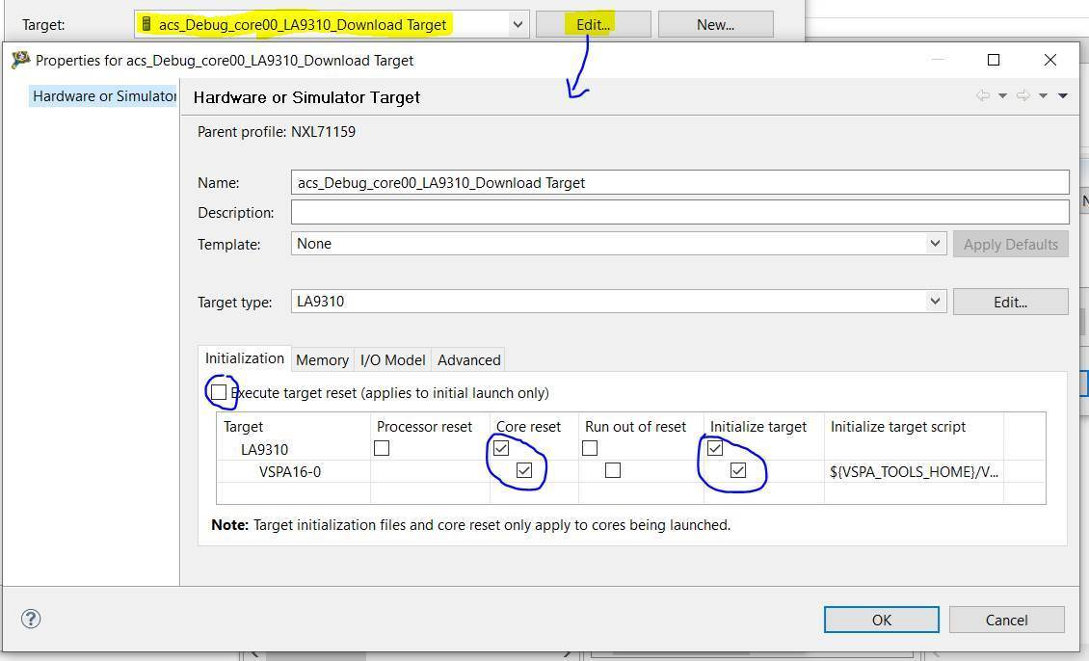

# Running the test

Open **Debugger Shell** and follow these steps

cd [repo]\project\script

source test_batch.tcl

Result should be

PPPPP AA SSSS SSSS

PP PP AAAA SS SS SS SS

PPPPP AA AA SS SS

PP AAAAAAAA SS SS

PP AA AA SS SS SS SS

PP AA AA SSSS SSSS